|  |  |
| --- | --- |
| **NOMENCLATURE** | |
| CMOD | Crack mouth opening displacement |
| CTOD | Crack tip opening displacement |
|  | Effective crack opening displacement |
| EDM | Electrical discharge machining |
|  | Tensile strain capacity |
|  | The ratio of girth weld flaw height to pipe wall thickness |
| Extrados | Tension side of a cold bend |
| HAZ | Heat affected zone |
| Intrados | Compression side of a cold bend |
|  | The Y/T ratio of the pipe base metal |
| LVDT | Linear variable displacement transducer |
| OD | Pipe outer diameter |
| PEEQ | Equivalent plastic strain |
| SENT | Single edge notch tension |
| SMYS | Specified minimum yield stress |
| t | Pipe wall thickness |
|  | The ratio of girth weld flaw length to pipe wall thickness |
| Y/T ratio | Ratio of the yield stress to the ultimate strength |

**1 – Introduction and Literature Review**

Girth welded pipelines can be subjected to large amounts of longitudinal deformation due to a variety of conditions. In case of onshore pipelines the main causes of high longitudinal deformations are seismic activity, slope instability, frost heave and the gradual sinking of landforms to a lower level as a result of mining operations. In case of offshore pipelines the highest deformations occur in the process of pipe laying by reeling where the girth welded segments of a pipeline is wound onto a spool and therefore experiences high bending strains. Fabrication flaws in girth welds are one of the major conditions leading to the failure of a pipeline due to excessive tensile strain. In order to prevent the failure of a pipeline due to these high strain levels the inevitable fabrication flaws in the girth welds have to be kept within acceptable limits. Another load case where pipeline failure due to tensile strains can occur is the application of bending strains on cold bent pipes. Experimental studies of Sen et al. [15],[19] showed that there is a likelihood of pipe body tension side failure in load cases of cold bends under internal pressure and bending.

The lack of knowledge about the effects of flaw sizes, internal pressure and material properties on the structural behaviour of a pipeline can have detrimental economical and environmental effects. In order to understand the structural behaviour of a pipeline in the presence of fabrication flaws and internal pressure it is necessary to conduct full scale tests of the pipe for different crack sizes and internal pressure levels. The research conducted in this field in the recent years focused on pipelines with steel grades X65 and higher. Particularly the research conducted by Wang et al [1],[2],[3] lead to closed form equations which predict the tensile strain capacity of a pipeline as a function of girth weld flaw dimensions and pipe base metal mechanical properties. These equations were included in the CSA code for oil and gas pipeline systems Z662-11 [20]. However it is not recommended to apply these equations in case of pipes with steel grade X52. Also the effect of internal pressure on the tensile strain capacity is not considered in the equations given in the CSA code. In the scope of this research project a total of 8 full scale tests will be conducted at different crack dimensions and different levels of internal pressure with pipe specimens of steel grade X52 (Table 1). The outcome of this experimental study is expected to provide new insights about the acceptability of girth weld flaw sizes and structural behaviour under excessive tensile loading in case of X52 vintage pipes. Also the experimental studies of Sen et al. are further investigated using finite element analysis in order to have a better understanding of the conditions which lead to a tension side failure of cold bent pipes.

**1.1 - Weld Defects Classification and CSA Z662.11**

The Canadian Standards Association Code of Practice CSA Z662.11 [20] classifies possible weld defects as surface breaking and buried (Figure 1). Surface breaking defects are those resembling a crack that is connected to the surface of the pipe wall, whereas buried defects are those that are not connected to the surface of the pipe wall. Although the surface breaking defect is depicted in Figure 1 on the inner surface of the pipe wall, the CSA code doesn’t distinguish between surface flaws on the inner surface and those on the outer surface. According to Z662.11, in the absence of experimental data, the critical tensile strain of the pipe material () can be calculated based on Eq. (1) and Eq. (2) corresponding to the crack types depicted on the left and right side of Figure 1 respectively.

|  |  |
| --- | --- |
| surface defect | buried defect |

Figure 1: Classification of weld defects according to CSA Z662.11 as surface breaking (left) and buried (right) [20]

|  |  |  |
| --- | --- | --- |
|  | | () |
|  | | (2) |
|  |
|  |

Eq. (1) and Eq. (2) are developed based on the extensive experimental work conducted by Wang et al [1],[2],[3],[4],[5] on curved wide plates with machined defects. However, the code specifies high values of toughness as a limitation to using these equations, indicating that these equations were developed for modern steel pipelines. In addition, the code specifically warns that the effect of internal pressure on the longitudinal strain capacity is not considered in the equations and experienced judgement needs to be used or testing needs to be conducted to verify the behaviour under the effect of internal pressure. Thus, in order to predict the longitudinal tensile strain capacity of Enbridge X52 vintage pipeline it is imperative to conduct full scale experiments and toughness tests for a possible range of defects under the effect of both internal pressure and longitudinal tensile forces.

**1.2-Research Conducted on Tensile Strain Capacity of Pipelines using Curved Wide Plate Tests**

Due to the difficulty associated with full scale testing of pressurized pipes, full scale tests are usually conducted on curved wide plates (Figure 3) with machined defects. Wang et al. [6] developed a methodology of establishing strain based design criteria using the concept of crack tip opening displacement (CTOD). In this methodology the CTOD toughness of the pipe base metal from small scale material tests is compared to the CTOD value observed in the full scale tests. In this work CTOD of the full scale tests is also referred to as the crack driving strain. The critical strain is defined as the longitudinal strain value at the point where the CTOD in the full scale tests or finite element models reaches the CTOD toughness of the material. The location of the critical strain is chosen to be remote from the girth weld. Therefore this strain value is also called the remote strain. Wang et al [6] simulated numerous finite element models having surface defects with a variation of defect depth and weld strength mismatch ratio levels.

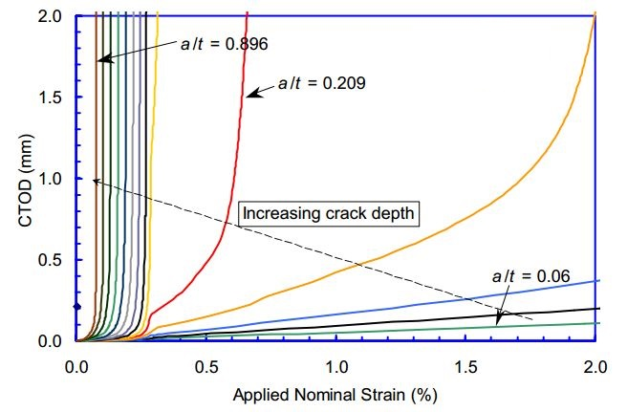

**R3**

**R2**

**R1**

Figure 2: Variation of the CTOD with respect to remote strain [6]

Figure 2 shows typical CTOD variations with respect to remote strain for different crack depth to pipe wall thickness ratios . In Figure 2 the CTOD variations are classified into the groups R1, R2, R3. These three groups are classified as unstable, stable-nonlinear and stable-linear variations of CTOD respectively. The outcome of these simulations was verified with an experimental program on curved wide plate tests performed by the University of Waterloo and the welding institute of Canada and published by Pick et al and Glover et al. [7],[8],[9]. It was concluded that the defect size is the most influential parameter affecting the tensile strain capacity. Also the results of the simulations were used to develop strain capacity prediction equations by curve fitting techniques.

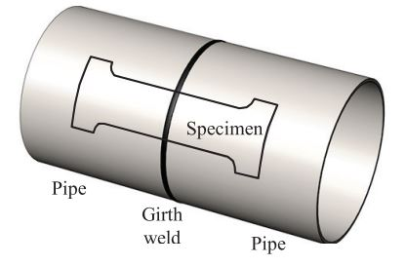

Figure 3: Position of a curved wide plate specimen [10]

In practice the remote strain in curved wide plate tests is measured using strain gauges. As a result the outcome and validity of these experiments are highly dependent on the chosen location for the strain measuring sensors. Hertele et al. [10] analyzed the effect of the remote strain sensor location in a study which includes curved wide plate tests as well as finite element simulations. In this study each side of the weld in the curved wide plate is assumed to be divided into three regions. The first of these regions is the vicinity of the weld. In order to define the boundaries of these regions a - coordinate system is introduced which has its origin at the point where a line starting from the crack center with degree angle from the plate midline intersects the plate edge. The second region is where and the third region is where . The first and third regions are assumed to have non-uniform strain distributions and the second region is divided into four partitions each being wide. The uniformity of the longitudinal strain is investigated for the second region at five different cross sections corresponding to . For each of these cross sections a dimensionless coefficient of variance is defined as the ratio of the standard deviation of the longitudinal strain along the cross section to the average longitudinal strain along the same cross section. Since changes as more deformation is applied on the specimen, another variable is defined which is the average value of over the entire test. Finally the cross section which exhibits the lowest value of is considered to have the most uniform longitudinal strain distribution.

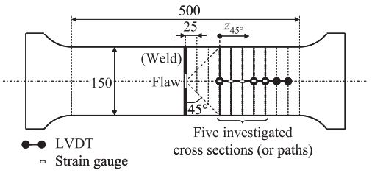

Figure 4: Division of the curved wide plate into uniform and non-uniform strain regions [10]

Wang et al [11] discussed the overview of tensile strain capacity prediction methodology developed by ExxonMobil [12]. This methodology is based on full scale tests, enrichment of strain capacity database with finite element simulations and small scale SENT (single edge notched tensile) tests for the measurement of the material CTOD toughness. Using these results and curve fitting techniques the following tensile strain capacity prediction equation is developed:

|  |  |  |
| --- | --- | --- |
|  | | (3) |
|  |

In Eq. (3) are the flaw depth, the half flaw length and pipe wall thickness respectively (Figure 1). The quantity represents the ratio of the flaw cross section area to the uncracked ligament cross section area. This dimensionless quantity provides a convenient way of visualizing the variation of the tensile strain capacity with respect to increasing flaw size (Figure 4 left). and in Eq. (3) are functions of flaw length, girth weld high – low misalignment, weld metal/ base metal strength mismatch ratio, ratio of the pipe base metal and the fracture toughness of the pipe base metal. Eq. (3) is developed for pipe grades X65 to X80. Wang et al. [13] compared the predictions of Eq. (3) with the results of full scale experiments with pressurized specimens for a variety of crack geometry and pipe material properties. The result of this comparison proved the validity of Eq. (3) (Figure 5 right).

|  |  |
| --- | --- |
|  |  |

Figure 5: Variation of tensile strain capacity with respect to flaw size (left) [11], and the validation of Eq. (3) using experimental results (right) [13]

**1.3- Research Conducted on Strain Capacity of Pressurized Pipelines**

Østby et al [14] carried out a full scale test program which included 6 pipe specimens. In these experiments a crack with 100 mm circumferential length is placed at the location of the pipe where the wall thickness was smallest. The crack depth to pipe wall thickness ratio was kept constant in all tests. Two of the experiments were carried out without internal pressure and in the remaining tests two different levels of internal pressure were tested corresponding to 25% SMYS and 60% SMYS hoop stresses. 4-point bending was applied in all tests. The steel grade was X65 for all tests. The strain measurements were made using strain gauges located 0.5 OD, 1 OD and 2 OD away from the center of the pipe. The CMOD of the flaw was measured using clip gauges with an attack point 0.2 mm below the external pipe surface. In order to measure the CTOD and crack growth (), silicone replicas of the flaws were made at different stages of the experiments. In this way the clip gauge measurements and the actual CTOD could be related to each other.

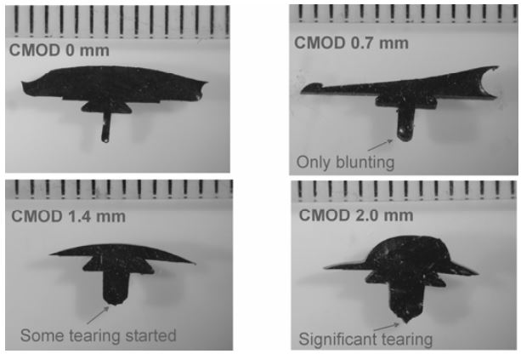

Figure 6: Silicone replicas of the flaw showing CMOD, CTOD and crack growth () at different stages of the test [14]

At the end of the experiments it was observed that the internal pressure significantly reduces the tensile strain capacity of the pipe from a level of 3.5 – 4 % to a level of 1.5 – 2%. Another observation was that the unpressurized specimens failed due to local buckling at the compression side whereas the pressurized specimens failed due to fracture at the flawed locations at the tension side. Østby et al [14] also introduced an alternative method to strain gauge measurements in order to obtain the bending strain. This method calculates the bending strain as where is the bending strain, is the outer radius of the pipe and is the radius of curvature. The comparison of the strain values calculated using this method with the average of measured strain values showed that the obtained strain values are consistent with each other.

Using the silicone replicas and numerical analysis, Østby et al [14] was able to create the crack growth resistance curves (curves showing the variation of CTOD with respect to ) of the full scale tests. The crack growth resistance curves of the full scale tests were compared to the curves obtained from small scale SENT tests. It was observed that the crack growth resistance curves obtained using these two methods are close to each other. This finding also justifies the determination of the tensile strain capacity as the strain at the point where CTOD (or CMOD) reaches the material toughness measured in the small scale tests.

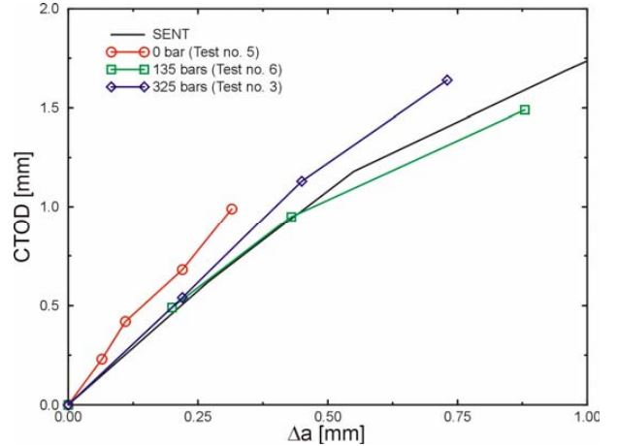

Figure 7: Comparison of the crack growth resistance curves from small scale (SENT) and full scale tests [14]

Gioielli et al [15] carried out pressurized and unpressurized full scale tests with six pipe specimens in order to investigate the effect of internal pressure on the tensile strain capacity of a pipeline. The specimens were grouped as three pairs and each pair had a different girth weld strength overmatch ratio. In each pair, one of the specimens was used for a pressurized test and the other one was used for an unpressurized test. The pressurized specimens had an internal pressure equivalent to 80% SMYS hoop stress and the unpressurized specimens had a negligible amount of internal pressure equivalent to 2% SMYS hoop stress which was applied in order to facilitate the leak detection. The girth weld strength overmatch ratios of the specimen pairs were 0%, 5% and 20%. All specimens had the steel grade X65, outer diameter of 12.75 inches (325 mm) and wall thickness of 0.562 inches (14.3 mm). Surface defects were machined on all specimens using electrical discharge machining (EDM) with equal crack dimensions of 3 mm depth and 50 mm length. Girth weld flaws were machined at three locations separated from each other at the girth weld centerline (Figure 8). The data collected in these experiments consists of the axial tensile load applied on the specimens, the overall elongation of the pipe due to axial loading, local strain measurements in longitudinal and hoop directions, crack mouth opening displacement (CMOD) and the internal pressure. The overall pipe elongation was measured using linear variable displacement transducers (LVDT). For the local strain measurements biaxial strain gauges were used at multiple locations on the pipe surface. The CMOD was measured using clip gauges. Acoustic emission monitoring was used to determine the point at which the ductile tearing of the crack initiated. The tensile strain capacities in these experiments were measured by dividing the total LVDT displacement at the moment of failure by the initial LVDT length. In the tests where the pipe failed away from the weld the tensile strain capacity was defined as the strain value at the point of maximum applied axial load. The test pairs with 0% and 5% strength overmatch exhibited tensile strain capacity decreases of 44% and 47% respectively due to internal pressure. In the tests with 20% strength overmatch the failre occurred away from the girth weld and the decrease of the tensile strain capacity due to internal pressure was 16%. The tensile strain capacities observed in this study are listed in Table 1. It was concluded that increasing girth weld strength overmatch ratio leads to a transition of the failure mode from ductile tearing at the girth weld flaw to plastic collapse away from the girth weld.

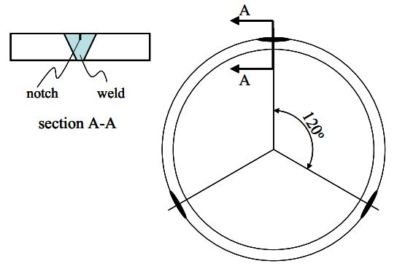

Figure 8: Placement of girth weld flaws [15]

Table 1: Measured Tensile Strain Capacities [15]

|  |  |  |  |
| --- | --- | --- | --- |
| **Girth weld strength overmatch ratio** | **Tensile Strain Capacity (%)** | | **Reduction of the tensile strain capacity due to internal pressure (%)** |
| **Pressurized** | **Unpressurized** |
| 0% | 1.9 | 3.4 | 44 |
| 5% | 1.9 | 3.6 | 47 |
| 20% | 4.6 | 5.5 | 16 |

Igi et al [16] conducted a pressurized full scale test, a curved wide plate test which represents the unpressurized load case, small scale single edge notch tension (SENT) tests as well as finite element analyses in order to develop a methodology for the prediction of the tensile strain capacity in the presence of internal pressure and surface defects. The specimens were taken from X80 pipeline with an outside diameter of 508 mm (20”) and a wall thickness of 14.3 mm (0.563”). The surface defects were machined into the heat affected zone (HAZ) of the girth weld using EDM. The SENT tests were used to determine the variation of the effective crack opening displacement () with respect to ductile crack growth (). This variation is denoted as the material resistance curve (R-curve). The finite element simulations were used to plot the variation of with respect to global strain. The global strain was calculated from the increase of axial distance between two points in the finite element models.

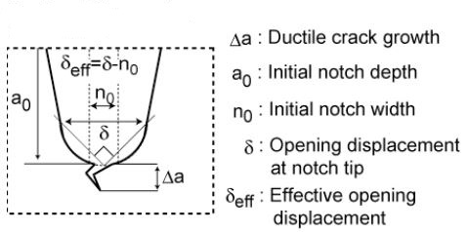

Figure 9: Longitudinal cross section of the flaw [16]

A series of finite element simulations were carried out with predefined dimensions. For each finite element simulation a curve showing the variation of with respect to global strain was plotted. In the next step on each of these curves a point was marked which shows the value that was observed in the SENT test for the corresponding level of . Once all curves are marked with a point, these points are joined which gives another curve with increasing slope. Finally the tensile strain capacity is defined as the global strain at the point where the curve which joined the marked points seems to have infinite slope. The procedure of calculating the tensile strain capacity from finite element simulations is also illustrated in Figure 10.

nd

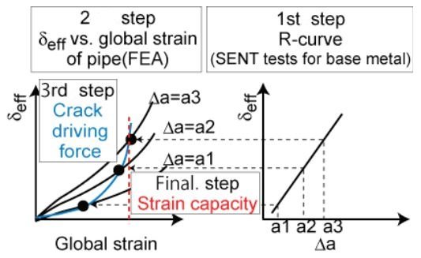

Figure 10: Calculation of the tensile strain capacity using finite element analysis and SENT tests [16]

The effect of internal pressure was investigated by comparing the results of the pressurized full scale test to the results of a curved wide plate test. It was observed that the tensile strain capacity decreases approximately 50% due to the internal pressure.

**1.4- Research Conducted on Cold Bent Pipes**

Fukuda et al [15] investigated the longitudinal strain distribution of cold bends and the decrease in the yield stress due to cold bending experimentally and numerically. Full scale cold bending experiments were carried out with two different pipes (denoted Pipe A and Pipe B in the rest of the text) of steel grade X60 and X80. The residual strains were measured using strain gauges on the line of maximum compressive strain in the longitudinal direction. It was found that the length of the longitudinal range where the compressive strain exceeds 0.2% is almost equal to the outer diameter of the pipe.

The mechanical properties of the pipes were tested before and after cold bending (Table 1).

Table 2: Mechanical properties before and after cold bending [15]

|  |  |  |  |
| --- | --- | --- | --- |
| **Pipe** | **Before and after bending** | **Yield stress [MPa]** | **Tensile Strength [MPa]** |
| A | Before | 465 | 527 |
| After | 437 | 529 |
| B | Before | 633 | 670 |
| After | 461 | 656 |

As it is shown in Table 1, due to cold bending the yield stresses of the pipe materials were reduced 6% and 27% for Pipe A (X60) and Pipe B (X80) respectively.

Caminada et al. [18] investigated the mechanical properties at extrados and intrados of cold bends. These mechanical properties are compared to those of straight pipes. Pipes with ASTM grade T23, T91 and T92 were cold bent by industrial rotary bending machines in form of U bends with a bending angle of . A total of 21 cold bends were tested with R/OD ratio ranging between 1.0 and 4.5. For the assessment of the mechanical properties, tension tests, Charpy impact tests and creep-rupture tests. The specimens for material testing were cut out of a cold bend with an outer diameter of 76 mm (3”) and a wall thickness of 12.5 mm (0.5”). Specimens were cut out of intrados, extrados and unbent portions of the pipe. The results of the tension tests showed that the yield stress at the extrados was on average 40% higher that the yield stress of the unbent pipe. On the other hand the yield stress at the intrados was on average 20% lower than the yield stress of the unbent pipe. From the results of the Charpy impact tests no correlation was observed between the locations where the test specimens were cut from and the absorbed energy in the tests. The tubes with grade T23 exhibited lower Charpy toughness than the grades T91 and T92. The results of the creep-rupture tests showed that the intrados and extrados have similar creep-rupture strength, whereas the specimens from the intrados exhibited higher creep-rupture ductility than the specimens from the extrados.

Sen et al. [19] tested one straight pipe and seven cold bend pipes under internal pressure and bending loads in order to have a better understanding of the allowable strains that a cold bend can undergo before local buckling occurs. Also the post-buckling behaviour of the cold bends were investigated. The steel grades of the specimens were X60, X65 and X80. 40%, 60% and 80% SMYS internal pressure levels were tested. In these experiments the bending load was applied in form of an eccentric compressive force which increases the curvature of the cold bend longitudinal axis. The curvature was applied after filling the pipe with water and bringing the internal pressure to the maximum level with a pneumatic pump. Both ends of the cold bends were closed with end plates welded to the pipe wall. These end plates were also connected to moment arms used for the application of the eccentric load (Figure 14). The portions of the cold bends adjacent to the end plates were prevented from ovalization. This condition was causing a stress concentration adjacent to the end plates making the pipe prone to local buckling at these locations. In order to prevent local buckling near the end plates, collars were installed at the ends of the specimen after the internal pressure was at the desired level.

The test results showed that in the post-buckling phase of the experiments, the load carrying capacity of the unpressurized specimens decreased more severely that the pressurized ones. Also the peak moments of the unpressurized specimens were less than the peak moments of the pressurized specimens. It was also demonstrated that the maximum curvature that the unpressurized specimens could undergo prior to buckling was in average 71% of the maximum curvature that the pressurized specimens could undergo prior to buckling. The comparison of the peak moments measured in two unpressurized tests showed that the effect of the OD/t ratio of the cold bend on the peak moment is greater than the effect of the yield stress of the pipe base metal on the peak moment since the specimen with lower OD/t ratio and lower yield stress exhibited higher peak moment. The comparison of the maximum moment and corresponding curvature of cold bent and straight pipes showed that these quantities are decreased due to cold bending. The average critical strain (the maximum strain prior to the formation of local buckling) of a cold bent specimen was measured as 48% of the critical strain of the straight specimen where all specimens have similar dimensions.

**2 - Problem statement:**

To date the research on pipeline structures mostly focused on the buckling of different pipe configurations under compressive forces. Such research projects were carried out to investigate the buckling and fracture of pipe walls under compressive loading. The research projects [1], [2], [3] are some examples of experimental studies which analyzed the occurrence of local buckling in the form of wrinkles in the pipe wall due to bending. On the other hand there is a limited amount of research projects studying the tensile strain capacity of pipeline that considers the effect of the internal pressure.

Different mathematical descriptions of the tensile strain capacity of pipes are available in the literature in the form of prediction equations. Some of these are incorporated in the CSA code for Pipeline Systems Operation (CSA Z662). However there is no well-established method for predicting the tensile strain capacity under internal pressure and the current equations in the CSA code don’t consider the effect of internal pressure on . Also none of the currently available methods for tensile strain capacity prediction are applicable to vintage pipes with steel grade X52. The current equations in the literature assume a steel grade of X65 or higher. These conditions make it necessary to investigate the strain response of X52 pipes under internal pressure.

Cold bending is applied in order to change the direction of a pipeline in a horizontal or vertical plane. This can be necessary to conform with the terrain conditions. Cold bending is done on site using cold bending machines. In the process of cold bending the material properties of the tension and compression side can be affected differently since the compression side (intrados) of the pipe can be loaded beyond the yield stress in compression whereas the tension side (extrados) can be loaded beyond yield stress in tension. In case of the occurrence of local buckling in form of a wrinkle at the compression side, the wrinkled part of the cold bend experiences high tensile strains and is more likely to fail due to tensile strain than the tension side. However, experimental studies carried out by Sen et al [1], [2] demonstrated that failure of a cold bend at the tension side can occur earlier than compressive failure under certain loading configurations. However, the level of internal pressure at which such failure mechanism can occur is not well understood.

Pipes may undergo tensile strain due to a variety of reasons (see section 1). These strains can be detrimental if they exceed the tensile strain capacity of the pipe. It is crucial to develop an alarm mechanism which informs the pipeline operators when there is a danger of pipeline failure due to excessive tensile strain. This alarm mechanism should be based on criteria that define the likelihood of a pipe failure. In this research project we are concerned with defining failure criteria which consider the effect of internal pressure on the tensile strain capacity of pipes. We are analyzing the effect of internal pressure on the tensile strain capacity from two different viewpoints. Firstly, we are conducting full scale tests in which we load vintage girth welded pipes with tensile forces and internal pressure in the presence of a flaw in the heat affected zone of the girth weld. By varying the amount of pressure and the flaw size we are analyzing the effect of these parameters on the tensile strain capacity of the pipe. The second viewpoint is the analysis of cold bend pipe failure at the tension side. Our initial work showed that the occurrence of this mode of failure of a cold bend highly depends on the amount of applied internal pressure.

**3- Objectives and Specific Aims**

The main objective of this research is to identify the structural behaviour of pipes under tensile strain and to define the corresponding failure criteria. In the scope of this research the strain response of X52 vintage pipes with girth weld flaws under tensile forces and internal pressure is analyzed experimentally and numerically. Also previous experimental studies carried out by Sen et al [1], [2] are revisited in order to analyze them numerically and to define tensile failure criteria. The following outlines the two main objectives of this research along with their specific aims.

**Objective 1: Evaluating the Critical Strain Capacity of X52 Pipes.**

To achieve this main objective, we are proposing an experimental and numerical research program with the following specific aims:

**Specific aim 1.1:** Assessment of the sensitivity of CSA Z662.11 tensile strain capacity prediction equations to different geometric and material parameters.

**Specific aim 1.2:** Full Scale Experiments of X52 pipe

**Specific aim 1.3:** Developing a model for predicting the Tensile Strain Capacity of Girth welded X52 pipes.

**Specific aim 1.4:** Comparison between the different tensile strain capacity equations in the literature.

**Objective 2:** Developing generalized criteria for the tensile failure of cold bend pipes.

**Specific aim 2.1:** Numerical modelling of Sen et al experiments.

**Specific aim 2.2:** Developing a generalized model to predict the tensile failure of cold bend pipes

**Methods:**

**Objective 1: Evaluating the Critical Strain Capacity of X52 pipes.**

In order to achieve our objective, the current critical strain capacity equations available in the literature need to be studied and analyzed. Then, a full scale experimental study is designed to determine the critical strain capacity of X52 pipes with girth weld flaws under the effect of internal pressure. Finally, a numerical study is proposed in order to extend our experimental results and produce a prediction equation that is able to predict the strain capacity of X52 pipes as a function of the internal pressure and the flaw parameters. Following are the proposed methods to achieve our objective:

**Specific aim 1.1: Assessment of the sensitivity of tensile strain capacity prediction equations to different geometric and material parameters.** Different geometric parameters and material properties affect the tensile strain capacity of a pipe at different levels. Since our project consists of a limited number of full scale tests, it is not possible to test the effect of all parameters experimentally. Therefore it is necessary to narrow down the focus of the project to the most significant parameters affecting the tensile strain capacity. In order to achieve this, the sensitivity of the current CSA equations as well as other proposed equations in the literature should be analyzed with respect to changing magnitudes of different parameters. full factorial analysis technique is applied in order to investigate this sensitivity.

**Specific aim 1.2: Full Scale Experiments of X52 pipe.** In order to investigate the critical strain capacity of X52 pipes, a full scale experimental study is proposed in which two levels of internal pressure, two different flaw thicknesses and two different flaw lengths are combined to produce 8 full scale tests (Table 1). Each experiment has a different combination of girth weld flaw size and internal pressure. The parameters which define the flaw size are the flaw length to pipe wall thickness ratio and the flaw depth to pipe wall thickness ratio . According to the CSA code the allowable ranges for and are and . For and the flaw size is negligible according to the CSA code. Based on this information two different flaw depths (25% and 50% of the wall thickness) and two different flaw lengths (50mm and 150mm) are tested which gives us 4 different flaw size possibilities. The third variable internal pressure. In general, the internal pressure level is defined as the pressure leading to a circumferential stress of a certain percentage of the specified minimum yield strength (SMYS). The CSA code stipulates that the maximum operating pressure level is the 80%SMYS. For our tests, we are proposing 2 different levels (80% SMYS and 30%SMYS). With the addition of the internal pressure as the third variable a total of 8 different test configurations result each having a different combination of flaw depth, flaw length and internal pressure.

Table 3: Full Scale Test Matrix

| **Test number** | **Specimen length** | **Internal pressure (% SMYS)** | **Flaw length [mm]** | **Flaw depth [mm]** |
| --- | --- | --- | --- | --- |
| 1 | 72” | 80 | 50 | 1.7 |
| 2 | 72” | 30 | 50 | 1.7 |
| 3 | 72” | 80 | 50 | 3.4 |
| 4 | 72” | 30 | 50 | 3.4 |
| 5 | 48” | 80 | 150 | 1.7 |
| 6 | 48” | 30 | 150 | 1.7 |
| 7 | 48” | 80 | 150 | 3.4 |
| 8 | 48” | 30 | 150 | 3.4 |

**Machining the Girth Weld Flaw**

The flaws are machined in two stages using two different blades with thicknesses 0.012” and 0.006”. In the first stage the flaw is initiated with the 0.012” thick blade and cut up to a depth of 1.0 mm for the 1.7 mm deep flaw and up to a depth of 1.7 mm for the 3.4 mm deep flaw. In the second stage the blade is replaced with a 0.006” thick one and the rest of the flaw depth is cut. Before starting to cut the flaw it is checked with an L-shaped ruler that the pipe surface is perfectly perpendicular to the blade. During the flaw cutting process the pipe is located on roller stands. The circumferential length of the flaw is controlled with the rollers of the pipe stand and two magnets (G6 in Figure 1) on the pipe surface 50 mm or 150 mm apart from each other in the circumferential direction. The magnets stop the rotation of the pipe once 50 mm or 150 mm flaw length is reached. The depth of the flaw is increased in 0.05 mm steps and the depth is controlled using a dial indicator. There are two dial indicators denoted with G3 and G4 in Figure 1 showing the position of the blade in the directions parallel and perpendicular to the pipe surface respectively. G4 is brought to zero position at the beginning of the flaw cutting process once the blade touches the pipe surface and G3 is brought to zero position once the blade is aligned with the middle of the flaw location (within 5 mm distance from the girth weld). The position of the blade is adjusted using the x-y table denoted with G1 in Figure 1. An air driven motor (G2) is used to rotate the blade which is clamped between stiffeners and these stiffeners are connected to a steel block which is clamped in the x-y table. The blade-stiffener-steel block assembly is denoted with G7 in Figure 1.

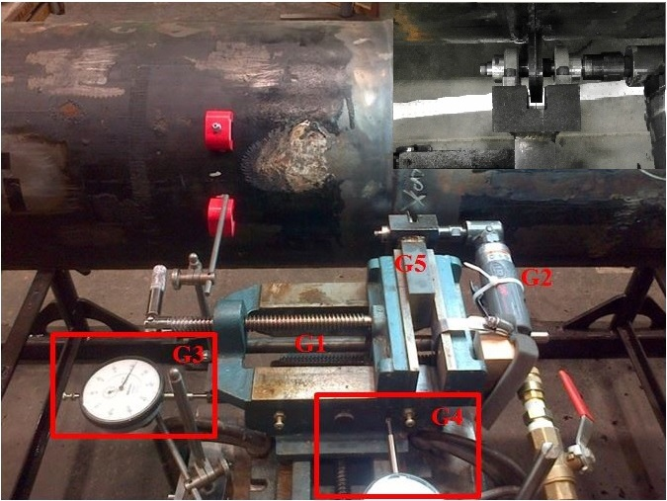

**G6**

**G7**

**G7**

Figure 11: Flaw Cutting Setup

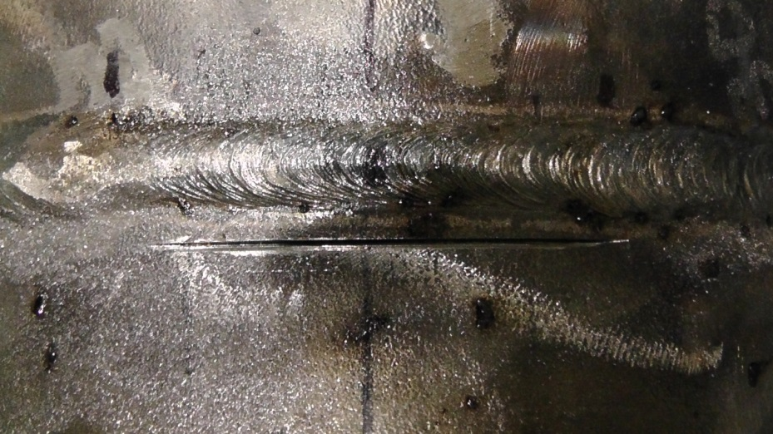

Figure 12: Flaw in the heat affected zone

**Loading the pipe:** (How and why?)

**Strain Measurements**

In each full scale experiment (Table 1) the longitudinal and hoop direction strains are measured with strain gauges at critical locations of the pipe. In addition to that, digital image correlation is used to obtain the variation of the strain field during each experiment at critical locations of the pipe. The results of these measurements are used to evaluate the tensile strain capacity of each specimen. The critical tensile strain is defined in the CSA code as the value of the global compressive strain at the onset of rupture. From our tests, we are proposing the following three different options for the evaluation of the tensile strain capacity of the full scale specimen:

**Option 1:** In the literature [4] the tensile strain capacity is defined as the average axial strain value at a uniform strain zone far away from the girth weld flaw location. In this case several strain gauges are mounted on this uniform strain zone. The average value of the strain measured by these strain gauges is called the remote strain.

**Option 2:** The tensile strain capacity of the pipe can be defined as the axial strain at the uniform strain zone closest to the girth weld flaw as observed in the image correlation.

**Option 3:** As an alternative to defining the tensile strain capacity as a single number for each test specimen, the critical strain profile could be defined in the longitudinal direction of the pipe. For this purpose the strain values from the digital image correlation and the strain gauge measurements are used in combination with each other. For the first two tests three measurements can be used to create the strain profile. These measurements are the strain value at 0.8 OD away from the end plate, the strain gauge measurement in the middle of the lower side of the pipe, and a strain measurement 0.7 OD away from the flaw.

The strain is measured using strain gauges and digital image correlation. For the image correlation, portions of pipe surface around the flaw and adjacent to the lower end plate are painted in white and speckled in a dark colour before the test. This is necessary since the image correlation method uses the initial and deformed positions of the speckles to calculate the strain field at different stages of the experiment. On the remaining parts, strain gauges are glued on the pipe surface at selected distances from the end plates. At each selected distance a ring which consists of four strain gauge couples (consisting of one axial and one hoop direction strain gauge) or single strain gauges (strain gauge only in axial direction) is used. These four strain gauge positions are 90 degrees apart from each other in the circumferential direction. Putting strain gauges at different positions around the circumference is necessary since the axial strain changes around the circumference due to the eccentricity of the applied displacement. Figure 3 shows four quarters of the pipe wall cross section denoted by to . In the middle of each quarter the corresponding strain gauge location is shown with red lines and a strain gauge label. Each strain gauge label starts with the letters standing for “strain gauge”. In the strain gauge labels the numbers to denote the angular distance of the gauge location from the flaw midline in degrees. The letters at the end of each label indicate that the gauge could be in axial or hoop direction.

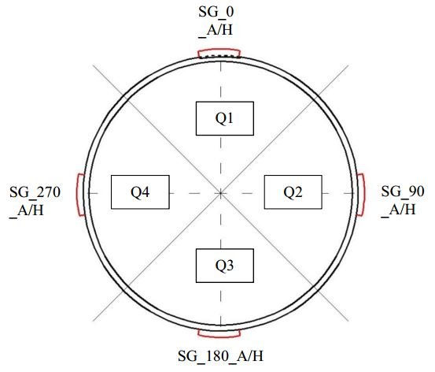

Figure 13: Strain gauge positions around the pipe circumference

**Specific aim 1.3: Developing a model for predicting the Tensile Strain Capacity of Girth welded X52 pipes.**

In the scope of this project we are aiming to develop a model which predicts the tensile strain capacity using three input variables. These variables are the same ones which take two different values in the full scale experiments: The ratio of flaw length to pipe wall thickness , the ratio of flaw depth to pipe wall thickness and the internal pressure . Since the experimental results are limited to two levels of each parameter, a finite element model is developed which can accurately simulate the strain response of the pipe in order to obtain predictions for further levels of the parameters for which no experimental data is available.

The combination of experimental and simulated results will provide us with a large database of strain responses based on which the model can be developed. The model will consist of Bezier surface equations corresponding to different levels of internal pressure. The surface equations will describe the variation of the tensile strain capacity with respect to and for selected levels of .

**Definition of the Bezier surfaces for the prediction of the tensile strain capacity**

Bezier surfaces are defined by a two dimensional grid of control points . In this project the experimental and simulated values constitute the control points. Let be any flaw size combination which is neither experimentally tested nor simulated. Let and be the lower and upper bounds for . The first step in defining the Bezier surface is to map and into the interval as follows:

Where and are the transformed versions of and such that . The equation describing the Bezier surface is constructed using Bernstein polynomials as shown in equation (1).

|  |  |
| --- | --- |
|  | (1) |

In equation (1), and denote one less of the number of control points in and directions respectively. and are called the Bernstein polynomials and their values are calculated as in equation (2).

|  |  |
| --- | --- |
|  | (2) |

The products in equation (1) are weight coefficients which define the contribution of the control point to which represents the predicted tensile strain capacity for the flaw configuration .

**Specific aim 1.4: Comparison between the different tensile strain capacity equations in the literature.**

Several research groups have introduced equations for the prediction of the tensile strain capacity based on full scale tests and finite element analysis. These equations have certain limits of applicability in terms of flaw size limits or material property limits. A common approach is to develop a system whose input consists of flaw dimensions, pipe geometry, material properties and whose output is the tensile strain capacity of the pipe having these geometry and material properties. Our objective is to make a comparison between outputs of each equation in order to have an understanding of their applicability to different scenarios and the possibility of utilizing them for X52 pipes. The following equations are currently available in the literature for the prediction of the tensile strain capacity ([7],[4],[6]) :

|  |  |
| --- | --- |
|  | (3) |
|  | (4) |
|  | (5) |

Table 4: Nomenclature for equations (3), (4), (5)

|  |  |  |
| --- | --- | --- |
| Equation (1) |  | Crack-tip opening displacement (CTOD) toughness [mm] |
|  | Ratio of yield strength to tensile strength (Y/T) |
|  | Ratio of flaw length to pipe wall thickness |
|  | Ratio of flaw height to pipe wall thickness |
| Equation (2) |  | Fitted functions of normalized geometry and material parameters |
|  | Girth weld CTOD toughness [mm] |
| Equation (3) |  | Functions of flaw size and pipe material properties |
| A | Flaw depth |
| C | Half flaw length |
| T | Pipe wall thickness |

**Objective 2: Developing generalized criteria for the tensile failure of cold bend pipes.**

Any alarm system for the prevention of the tensile failure of cold bends needs to be implemented based on well established failure criteria. In this study we are aiming at developing such failure criteria by simulating the structural behaviour of cold bends under the combination of bending and internal pressure. Experimental studies of Sen et al [1], [3] showed that cold bends under internal pressure and closing mode bending loads can fail at the tension side after the formation of wrinkles at the compression side pipe wall. This is an unexpected mode of failure because of the large deformations at the compression side of the cold bend in the post-buckling phase.

Table 5: Geometry and Material Properties of the Cold Bend

|  |  |
| --- | --- |
| Nominal diameter | 762 mm |
| Wall thickness | 8.2 mm |
| Grade | X65 |
| Curvature | Bent 1 degree per diameter in length |
| SMYS | 448 MPa |
| Internal pressure | 80% SMYS hoop stress |

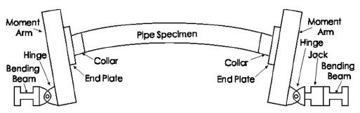

x

y

Figure 14: Experimental setup of the cold bend

**Specific aim 2.1:** **Numerical modelling of Sen et al experiments.**

In the scope of this research project, the load case and pipe geometry combination which lead to the tension side fracture of a cold bend in the experimental studies of Sen et al is simulated using finite element analysis. The objective of this simulation is to verify the outcome of the experimental studies of Sen et al and to obtain a better understanding of the conditions which lead to the tension side fracture of a cold bent pipe. Furthermore the numerical analysis of the strain distribution at the tension side of a cold bend for different load cases enables us to define failure criteria for the tension side failure mode of a cold bend pipe.

The finite element simulations are carried out for all steel grades (X60, X65, X80) tested in the experimental study of Sen[1]. In order to investigate the effect of the internal pressure level on the structural behaviour, a parametric study of the internal pressure is carried our for internal pressure values ranging between 1.93 MPa and 7.72 MPa which cause 20% SMYS and 80% SMYS hoop stress respectively. In these simulations the pipe geometry is meshed using 4-node general purpose shell elements with reduced integration (S4R). A non-linear isotropic hardening material behaviour is adopted in order to model the plastic material response. In this model, the relationship between the yield stress and the plastic strain is assumed to be non-linear between the initial yield stress and the ultimate strength. 237 mm long sections of the pipe next to the end plates are assigned a greater element thickness (16 mm) than the rest of the model (8.2 mm) in order to model the effect of the reinforcing collars (Figure 1) and to prevent an inappropriate buckling of the model due to the pipe - end plate interaction. The moment arm (Figure 1) is modeled using rigid beam and multi point constraints. The nodes on the left pipe edge (Figure 2, Figure 3) are connected to a reference point at the centroid of the cross section of the pipe edge using multi-point constraints. This reference point, on the other hand, is connected to another reference point 600 mm below in y-direction with rigid beam constraints. In the setup of Figure 1, the jack on the right hand side applies the displacement. This jack is connected to the moment arm with a pin-yoke assembly which is denoted as “hinge” in Figure 1. In the rest of this text this right hand side hinge is referred to as the “loading pin”. In the finite element model, the reference point located 600 mm below the pipe axis represents the loading pin.

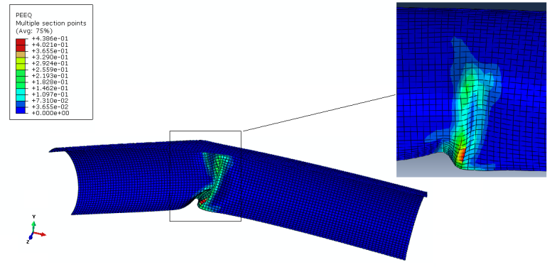

Figure 15: Plastic strain distribution under bending load without internal pressure

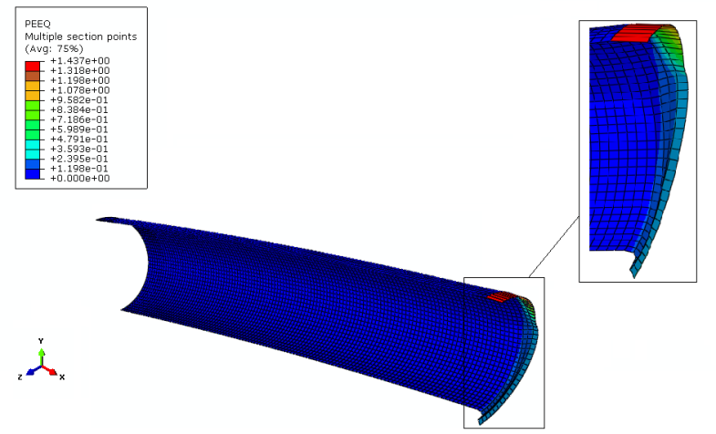

Figure 16: Plastic strain distribution under bending load and internal pressure

In order to increase the computational efficiency of the model, symmetry conditions are introduced. For this purpose symmetry planes parallel to x-y and y-z planes are introduced and one quarter of the entire cold bend pipe is simulated. As the first step of the simulations, internal pressure is applied on the inner surfaces of the pipe wall. In the parametric studies of the effect of internal pressure, the pressure value is varied between 1.93 MPa and 7.72 MPa which correspond to 20% SMYS and 80% SMYS hoop stress respectively. In the next step of the simulations a displacement load of 298.99 mm is applied to the loading pin in x-direction causing the closing mode bending stresses and increasing the initial curvature of the cold bend.

**Specific aim 2.2:****Developing a generalized model to predict the tensile failure of cold bent pipes**

The finite element simulations showed that the failure of a cold bent pipe at the tension side is limited to load cases with internal pressure. Furthermore the amount of internal pressure is a decisive factor for the failure mode. In order to define a failure criterion, the variation of the equivalent plastic strain with respect to applied curvature is plotted for different levels of internal pressure. These plots have revealed that starting from a certain level of internal pressure, the equivalent plastic strain at the compression side stays below 40% whereas the equivalent plastic strain at the tension side starts to exceed 40%. This internal pressure level is denoted as **transition pressure** in this text and can slightly change with respect to the steel grade of the pipe. Also for internal pressure levels below the transition pressure, the equivalent plastic strain at the compression side can exceed 40% whereas at the tension side it stays below 40%.

**4- Progress to Date**

**5- Schedule**

**6- Publications**

**References**

[1] Wang Y.Y., Chen Y. (2005), “Reliability Based Strain Design. Gas Research Institute Report 04/0146”, Des Plaines, IL.

[2] Wang Y.Y., Cheng W. (2004),”Guidelines on Tensile Strain Limits. Gas Research Institute Report 04/0030”, Des Plaines, IL.

[3] Wang Y.Y., Cheng W., Horsley D. (2004),”Tensile Strain Limits of Buried Defects in Pipeline Girth Welds ”, Proceedings of IPC2004, International Pipeline Conference, IPC2004-524

[4] Wang Y.Y. et al (2004), “Tensile Strain Limits of Girth Welds with Surface-Breaking Defects Part I – An Analytical Framework”, Proceedings of the 4th International Conference on Pipeline Technology, 235-249.

[5] Wang Y.Y. et al (2004), “Tensile Strain Limits of Girth Welds with Surface-Breaking Defects Part II – Experimental Correlation and Validation”, Proceedings of the 4th International Conference on Pipeline Technology, 251-266.

[6] Wang Y.Y., Rudland D., Denys R., Horsley D. (2002), “A Preliminary Strain Based Design Criterion for Pipeline Girth Welds”, Proceedings of 4th International Pipeline Conference, Calgary, IPC2002-27169

[7] Pick R. J., Glover A. G., Coote R.I. (1980),”Full Scale Testing of Large Diameter Pipelines”, Pipeline and Energy Plant Piping, Pages 357-366, DOI: 10.1016/B978-0-08-025368-8.50042-7

[8] Glover A.G., Coote R.I., Pick R.J. (1981), “Engineering Critical Assessment of Pipeline Girth Welds”, Proceedings of Conference on Fitness for Purpose Validation of Welded Construction, The Welding Institute

[9] Glover A.G., Coote R.I. (1984), “Full Scale Fracture Tests of Pipeline Girth Welds “, Circumferential Cracks in Pressure Vessels and Piping-Vol.2, PVP Vol.95

[10] Hertele S., de Waele W., Denys R., Verstraete M. (2012), “Investigation of Strain Measurements in (curved) wide plate specimens using digital image correlation and finite element analysis”, The Journal of Strain Analysis for Engineering Design, DOI:10.1177/0309324712445121

[11] Wang X., Kibey S., Tang H., Cheng W., Minnaar K., Macia M.L., Kan W.C., Ford S.J., Newbury B. (2011), “Strain – based Design – Advances in Prediction Methods of Tensile Strain Capacity”, Internation Journal of Offshore and Polar Engineering (ISSN 1053-5381) Vol. 21, No. 1, pp.1-7

[12] Kibey S., Wang X., Minnaar K., Macia M.L., Fairchild D.P., Kan W.C., Ford S.J., Newbury B. (2010): “Tensile Strain Capacity Equations For Strain-Based Design of Welded Pipelines”, Proceedings of the 8th International Pipeline Conference, IPC2010-31661

[13] Wang X., Barbas S.T., Kibey S., Gioielli P.C., Minnaar K. (2009), “Validation of Strain Capacity Prediction Comparison of Full-Scale Test Results to Predictions from Tearing Analysis Based on FEA”, Presented at 5th Pipeline Technology Conference, Ostend, Belgium

[14] Østby E., Hellesvik A.O. (2007), “Fracture Control – Offshore Pipelines JIP Results from Large Scale Testing of the Effect of Biaxial Loading on the Strain Capacity of Pipes with Defects”, Proceedings of the 17th International Offshore and Polar Engineering Conference, Lisbon, Portugal, July 1-6, 2007ISBN 978-1-880653-68-5

[15] Gioielli P.C., Minnaar K., Macia M.L., Kan W.C. (2007), “Large-Scale Testing Methodology to Measure the Influence of Pressure on Tensile Strain Capacity of a Pipeline”, Proceedings of the Seventh International Offshore and Polar Engineering Conference, ISBN 978-1-880653-68-5

[16] Igi S., Sakimoto T., Endo S. (2011), “Effect of Internal Pressure on Tensile Strain Capacity of X80 Pipeline”, Procedia Engineering 10 (2011) 1451–1456

[17] Fukuda N., Yatabe H., Kawaguchi S., Watanabe T., Masuda T. (2003), “Experimental and Analytical Study of Cold Bending Process for Pipelines”, Journal of Offshore Mechanics and Arctic Engineering, Vol. 125

[18] Caminada S., Cumino G., Cipolla L., Di Gianfrancesco A. (2009), “Cold bending of advanced ferritic steels: ASTM grades T23, T91, T92”, International Journal of Pressure Vessels and Piping 86 (2009) 853–861

[19] Sen M., Cheng J.J.R., Zhou, J. (2011): ” Behavior of Cold Bend Pipes under Bending Loads ”, Journal of Structural Engineering, Volume 137, Issue 5, DOI:10.1061/(ASCE)ST.1943-541X.0000219

[20] Sen M. (2006); “Behaviour of Cold Bend Pipes Under Combined Loads” Ph.D. dissertation, University of Alberta

[21] Das S. (2003);” Fracture of Wrinkled Energy Pipelines” Ph.D. dissertation, University of Alberta

[22] DelCol P.R., Grondin G.Y., Cheng R.J.J., Murray D.W. (1998);”Behaviour of Large Diameter Line Pipe Under Combined Loads”, University of Alberta, Department of Civil Engineering, Structural Engineering Report No. 224

[23] Wang Y-Y.,et al (2011); “Second Generation Models for Strain-Based Design. Contract PR-ABD-1-Project 2. Final Approved Report Prepared for the Design, Materials and Construction Technical Committee of Pipeline Research Council International, (PRCI) Inc.

[24] CSA Z662-11; Oil and gas pipeline systems - Sixth Edition; Update No. 1: January 2012